**LOW-LEVEL DESIGNS DOCUMENT**

**Hubba - LOGOUT**

Version 1.1

Prepared By: Development Hell

Class: CECS 491-04

Date: February 19, 2023

Github Repository**:**

[**https://github.com/DevelopmentHellaHell/SeniorProject**](https://github.com/DevelopmentHellaHell/SeniorProject)

**Team Leader**

Kevin Dinh

**Members**

Garrett Tsumaki

Bryan Tran

Jett Sonoda

Tien Nguyen

Darius Koroni

POC: [tien.nguyen10@student.csulb.edu](mailto:tien.nguyen10@student.csulb.edu)

**Revi**[**sion History**](https://github.com/DevelopmentHellaHell/SeniorProject/tree/main/TrainE_ProjectProposal)

| **Version** | **Overview** | **Date** |
| --- | --- | --- |
| v.1.0 | Initial LLD | 1/29/2023 |
| v.1.1 | Final draft | 2/19/2023 |

# Table of Contents

**Table of Contents** **3**

**High-Level Design** **4**

**Low-Level Design** **4**

Successful Use Cases 4

Failure Cases 5

**References** **7**

# High-Level Design

1. Activity flow - Client Logout request:

[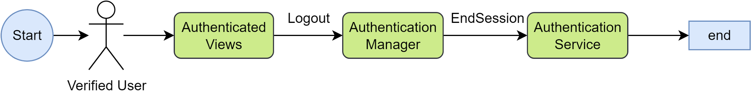](https://app.diagrams.net/?page-id=C5RBs43oDa-KdzZeNtuy&scale=auto#G1dXOH4TJamngh3tJhmtC-f1rMpDpcYGXH)

1. Activity flow - System Logout response:

[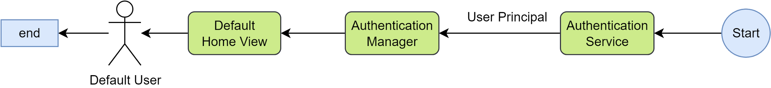](https://app.diagrams.net/?page-id=ujFSCu8-jrBLlHz-gM7Y&scale=auto#G1dXOH4TJamngh3tJhmtC-f1rMpDpcYGXH)

# Low-Level Design

**User story**: As a verified user, I can log out by sending a logout request. System will navigate me to the Home view after logging out successfully.

**Business rules**:

1. Any authenticated user can request logout to end their active authenticated session.
2. System failure from this feature will not cause the system to go offline.

**Preconditions**:

1. User must be authenticated and has an active session on the current device. If not, this operation is not an option to view.
2. User must be on view with the Logout option.

## Successful Use Cases

1. User performs logout request. The active session ends. The user is automatically navigated to the default home view of the system with the default culture settings. A system message displays “Logout successfully” upon completion of automatic navigation to home view. The logout process completes within 5 seconds upon invocation.
2. If the user is not authenticated, then the system should not allow log out.
   * Step 5: refer to Logging LLD Document[1]

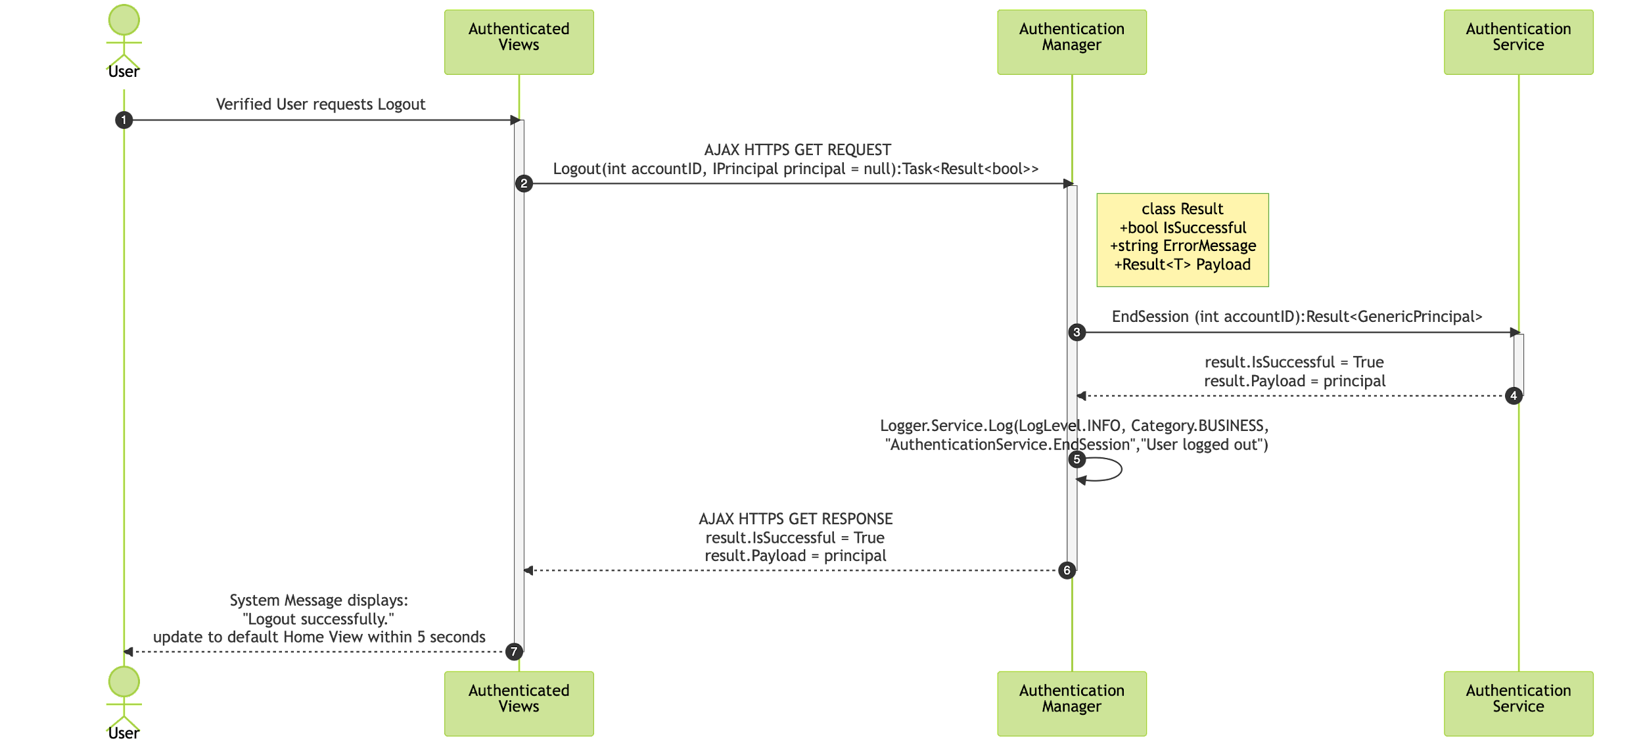

## Failure Cases

1. User performs logout request. System fails to end user’s session. User is still logged in. System message displays “Logout Operation Error, refresh page or try again later.”

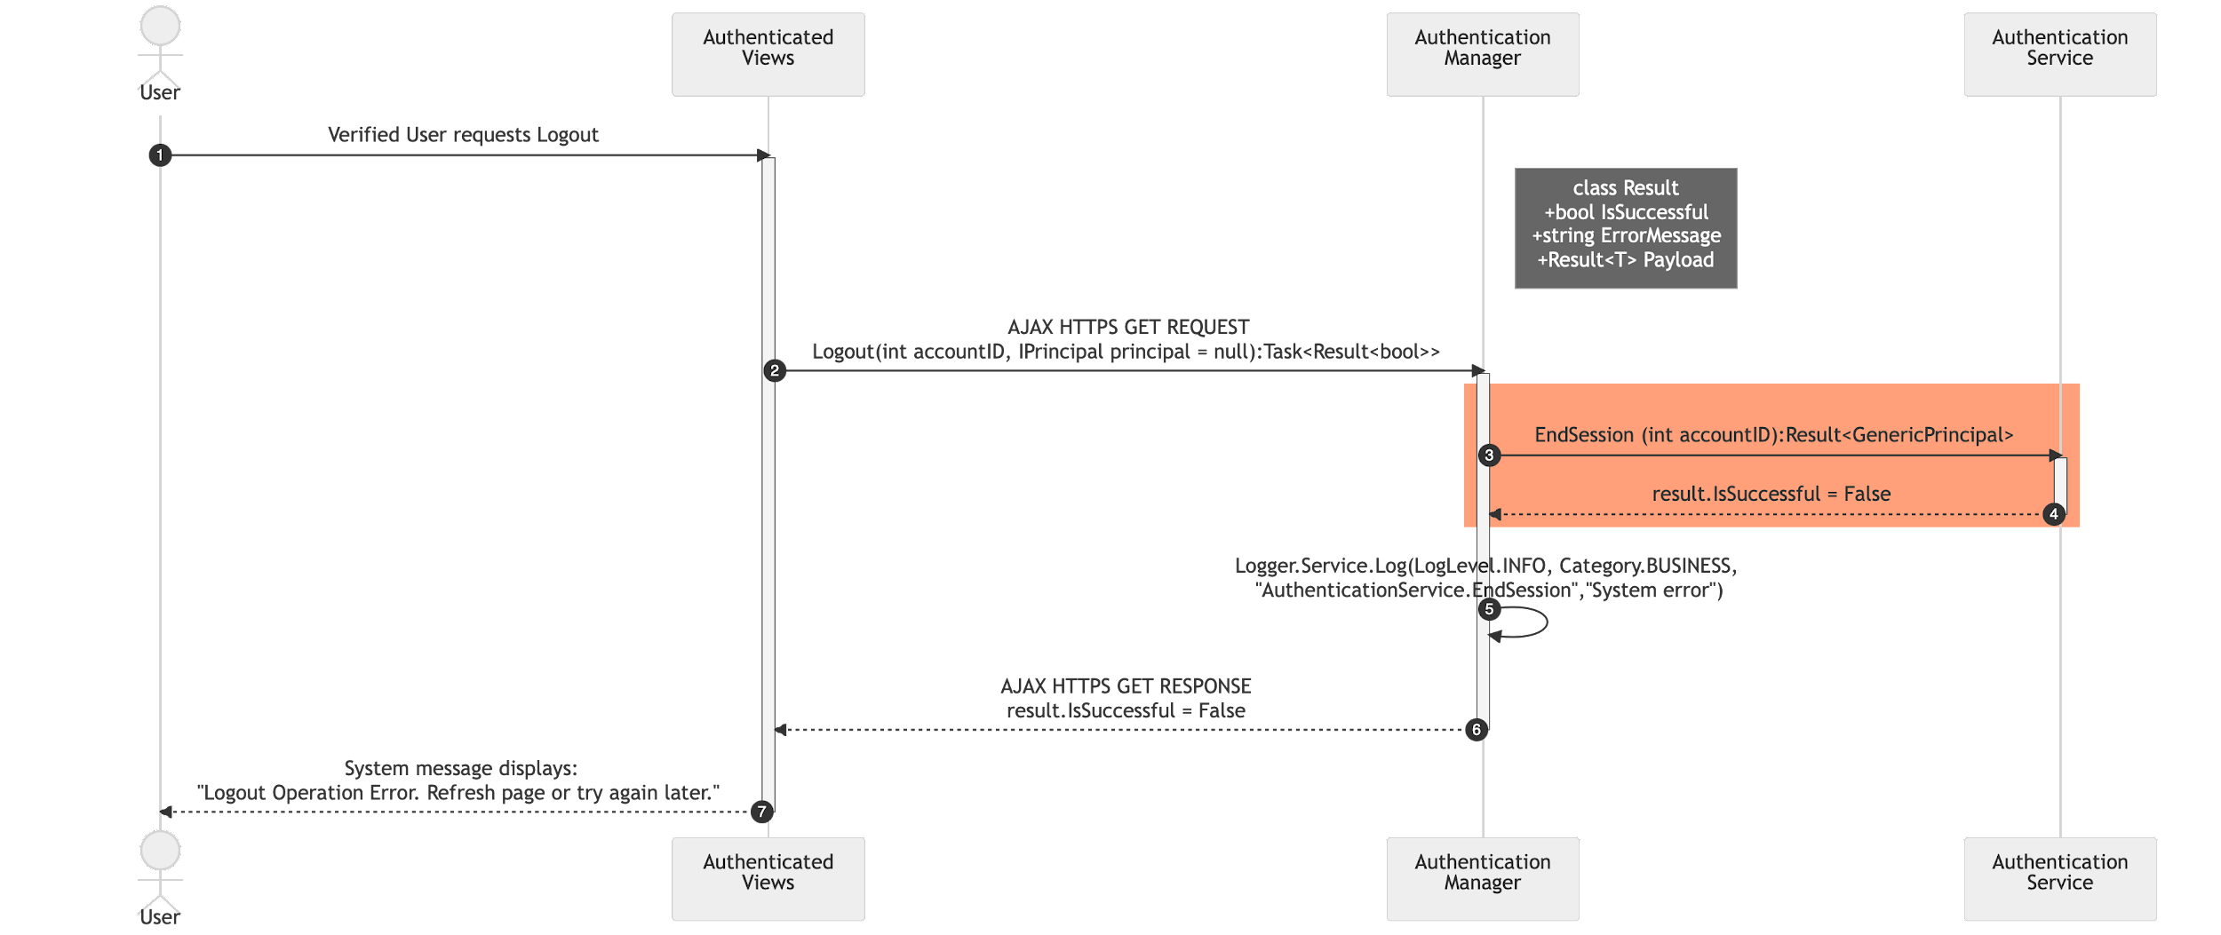

1. User performs logout request. The active session has ended. System message doesn’t appear after the successful logout.

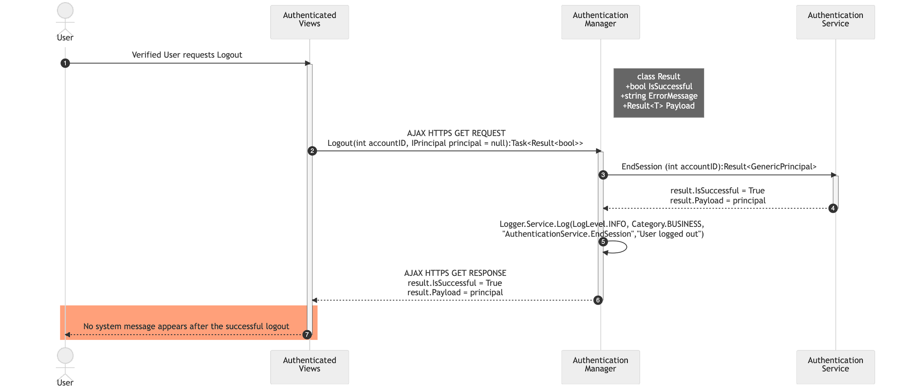

1. User performs logout request. The active session has ended. The user is not automatically navigated to the default home view. No message is shown.

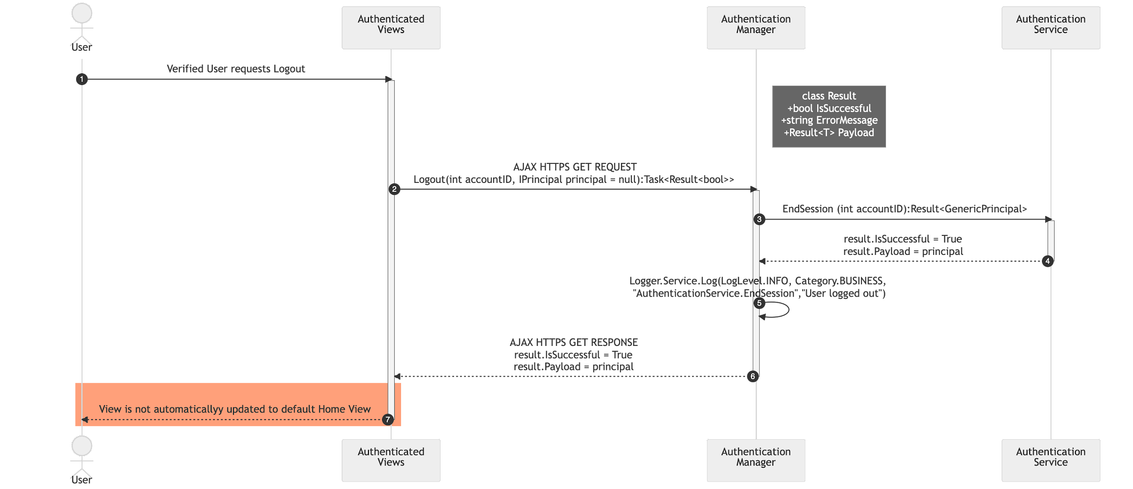

4. User performs logout request. The active session has ended. The user is automatically navigated to the default home view, but not set to the default culture settings. No message is shown

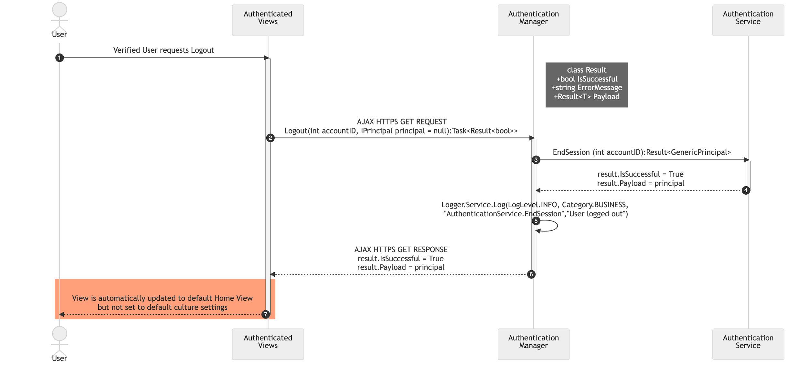

5. The logout process takes longer than 5 seconds.

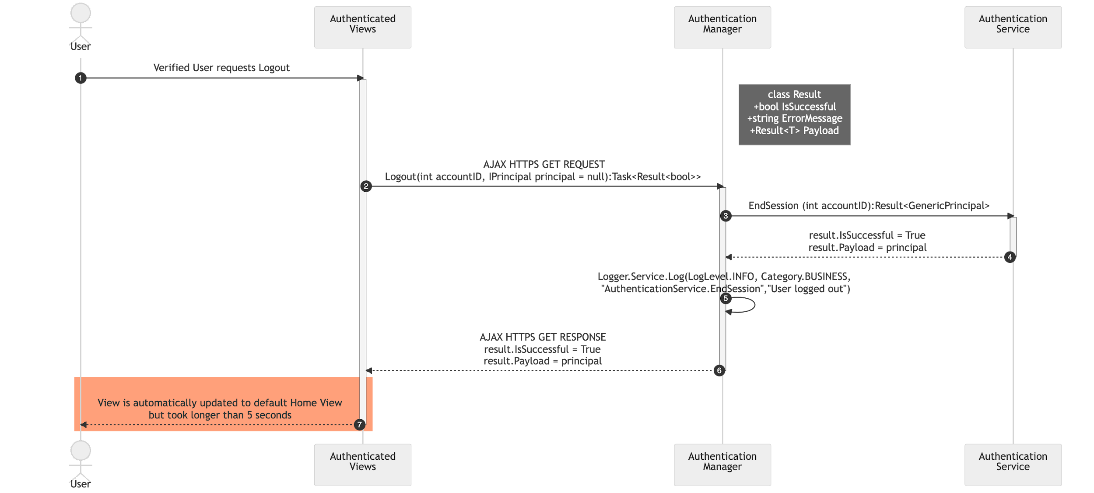

# References

This document elaborates client’s requirements[2] for one of the product’s core components - LOGOUT.

The requirement is designed based on the system architecture provided in High-Level Design Document[3].

The diagrams included in this document utilized diagrams.net[4] and Mermaid.js[5].

1. Logging LLD Document URL:
2. Client’s email, 10/17/2020
3. High-Level Design Document, URL: https://github.com/DevelopmentHellaHell/SeniorProject/blob/b43182c4076d471ef03520052675f1f88371dafd/docs/HL%20Design/DevelopmentHell%20HLD%20v1.2.pdf
4. https://www.diagrams.net/
5. https://mermaid-js.github.io/mermaid/#/